Raw code

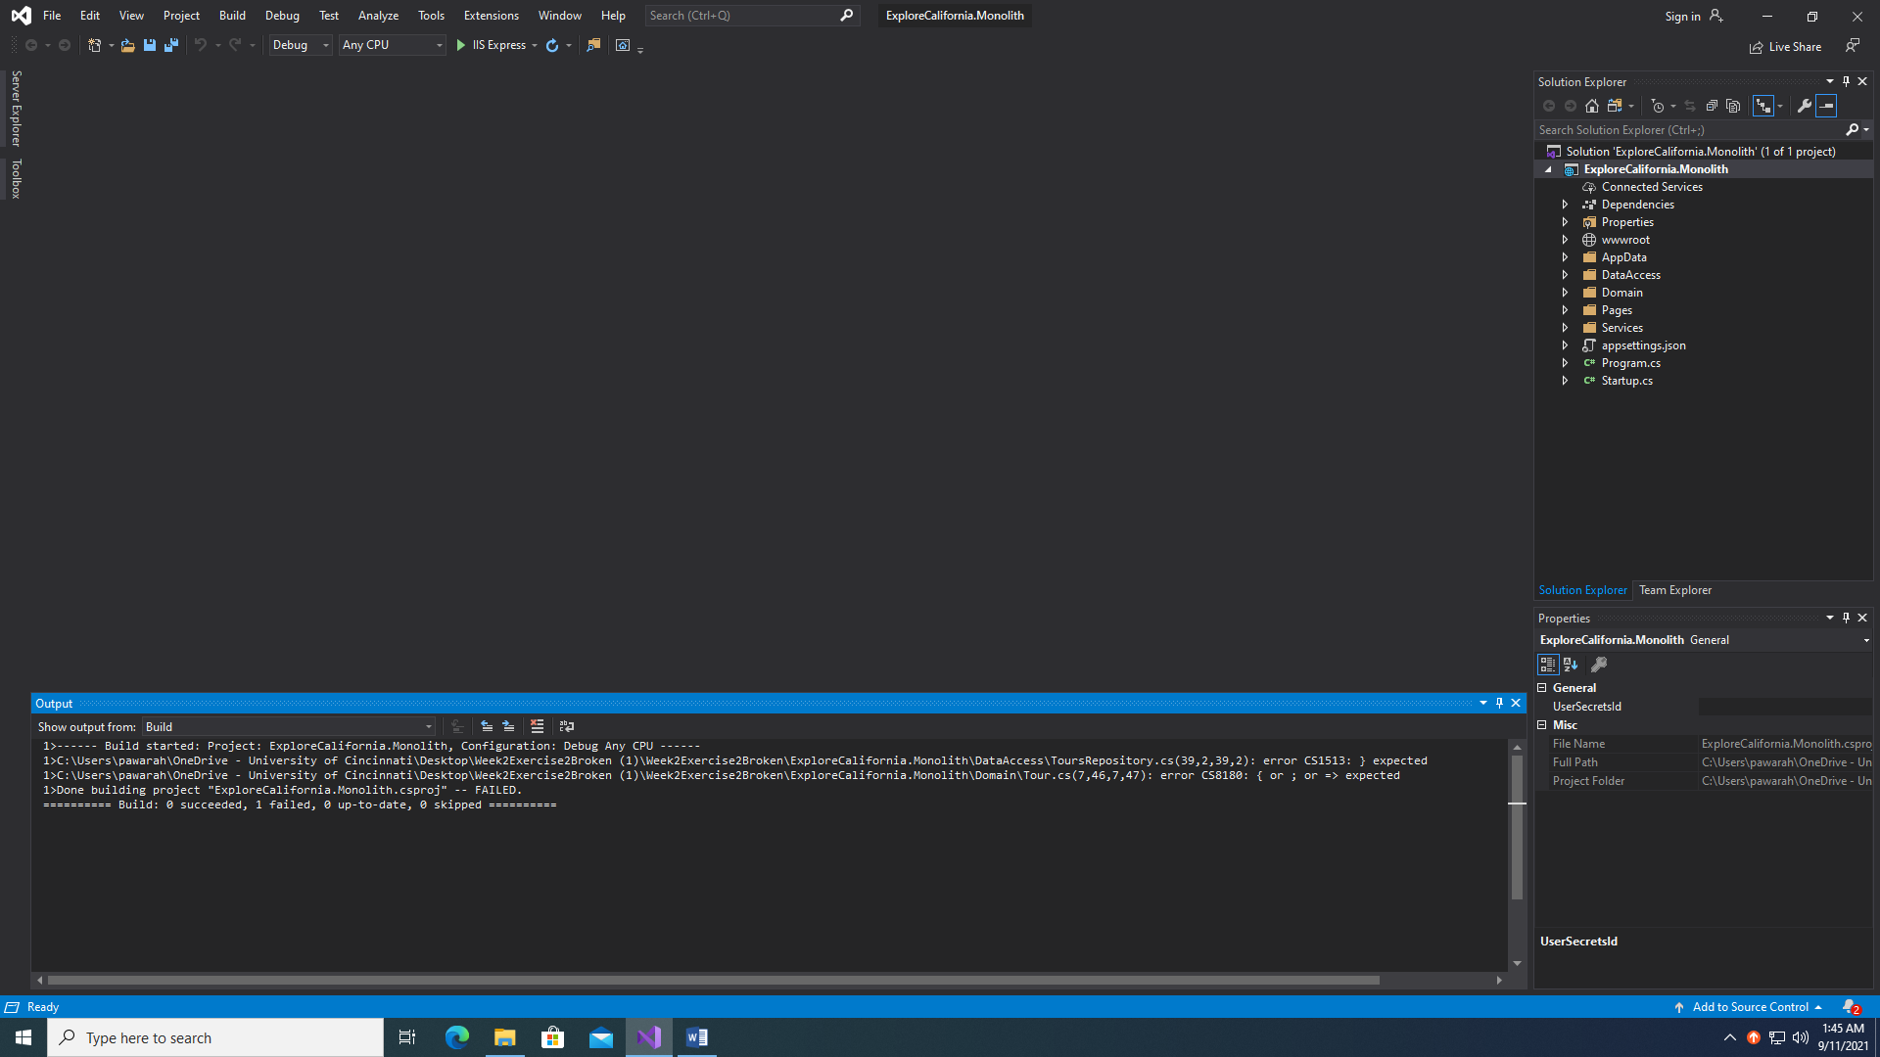

1>------ Build started: Project: ExploreCalifornia.Monolith, Configuration: Debug Any CPU ------

1>C:\Users\pawarah\OneDrive - University of Cincinnati\Desktop\Week2Exercise2Broken (1)\Week2Exercise2Broken\ExploreCalifornia.Monolith\DataAccess\ToursRepository.cs(39,2,39,2): error CS1513: } expected

1>C:\Users\pawarah\OneDrive - University of Cincinnati\Desktop\Week2Exercise2Broken (1)\Week2Exercise2Broken\ExploreCalifornia.Monolith\Domain\Tour.cs(7,46,7,47): error CS8180: { or ; or => expected

1>Done building project "ExploreCalifornia.Monolith.csproj" -- FAILED.

========== Build: 0 succeeded, 1 failed, 0 up-to-date, 0 skipped ==========

**Error**

1>C:\Users\pawarah\OneDrive - University of Cincinnati\Desktop\Week2Exercise2Broken (1)\Week2Exercise2Broken\ExploreCalifornia.Monolith\DataAccess\ToursRepository.cs(39,2,39,2): error CS1513: } expected

Sol - Added end bracket on line 39

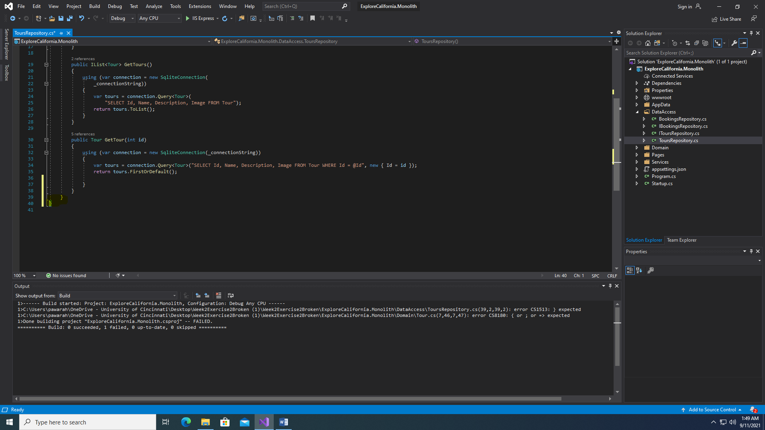

**Error:**

1>C:\Users\pawarah\OneDrive - University of Cincinnati\Desktop\Week2Exercise2Broken (1)\Week2Exercise2Broken\ExploreCalifornia.Monolith\Domain\Tour.cs(7,46,7,47): error CS8180: { or ; or => expected

Solution - public string Description { get; set; }

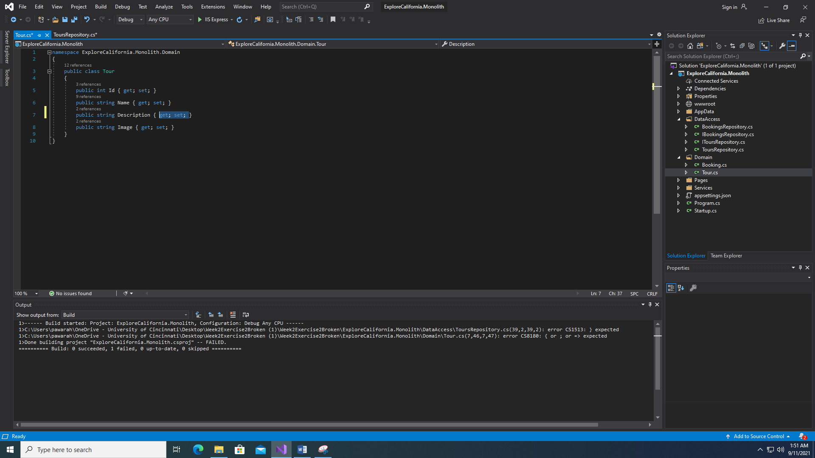

Added semicolon

**ERROR**

1>------ Build started: Project: ExploreCalifornia.Monolith, Configuration: Debug Any CPU ------

1>CSC : error CS5001: Program does not contain a static 'Main' method suitable for an entry point

1>C:\Users\pawarah\OneDrive - University of Cincinnati\Desktop\Week2Exercise2Broken (1)\Week2Exercise2Broken\ExploreCalifornia.Monolith\DataAccess\BookingsRepository.cs(22,67,22,71): error CS1061: 'Booking' does not contain a definition for 'name' and no accessible extension method 'name' accepting a first argument of type 'Booking' could be found (are you missing a using directive or an assembly reference?)

1>Done building project "ExploreCalifornia.Monolith.csproj" -- FAILED.

========== Build: 0 succeeded, 1 failed, 0 up-to-date, 0 skipped ==========

Solution - new { TourId = booking.TourId, Name = booking.Name, Email = booking.Email, Transport = booking.Transport });

Changed “n” to “N”

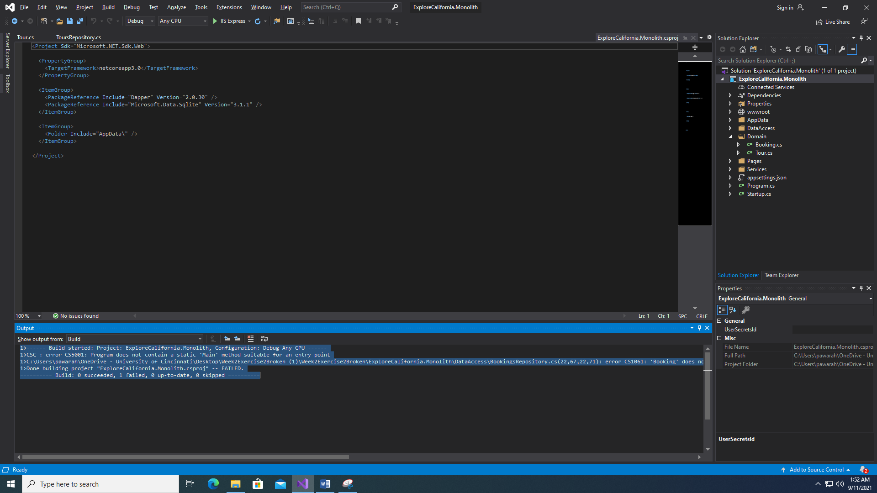

**ERROR**

1>CSC : error CS5001: Program does not contain a static 'Main' method suitable for an entry point

Solution - public static void Main(string[] args)

Changed the Main spell

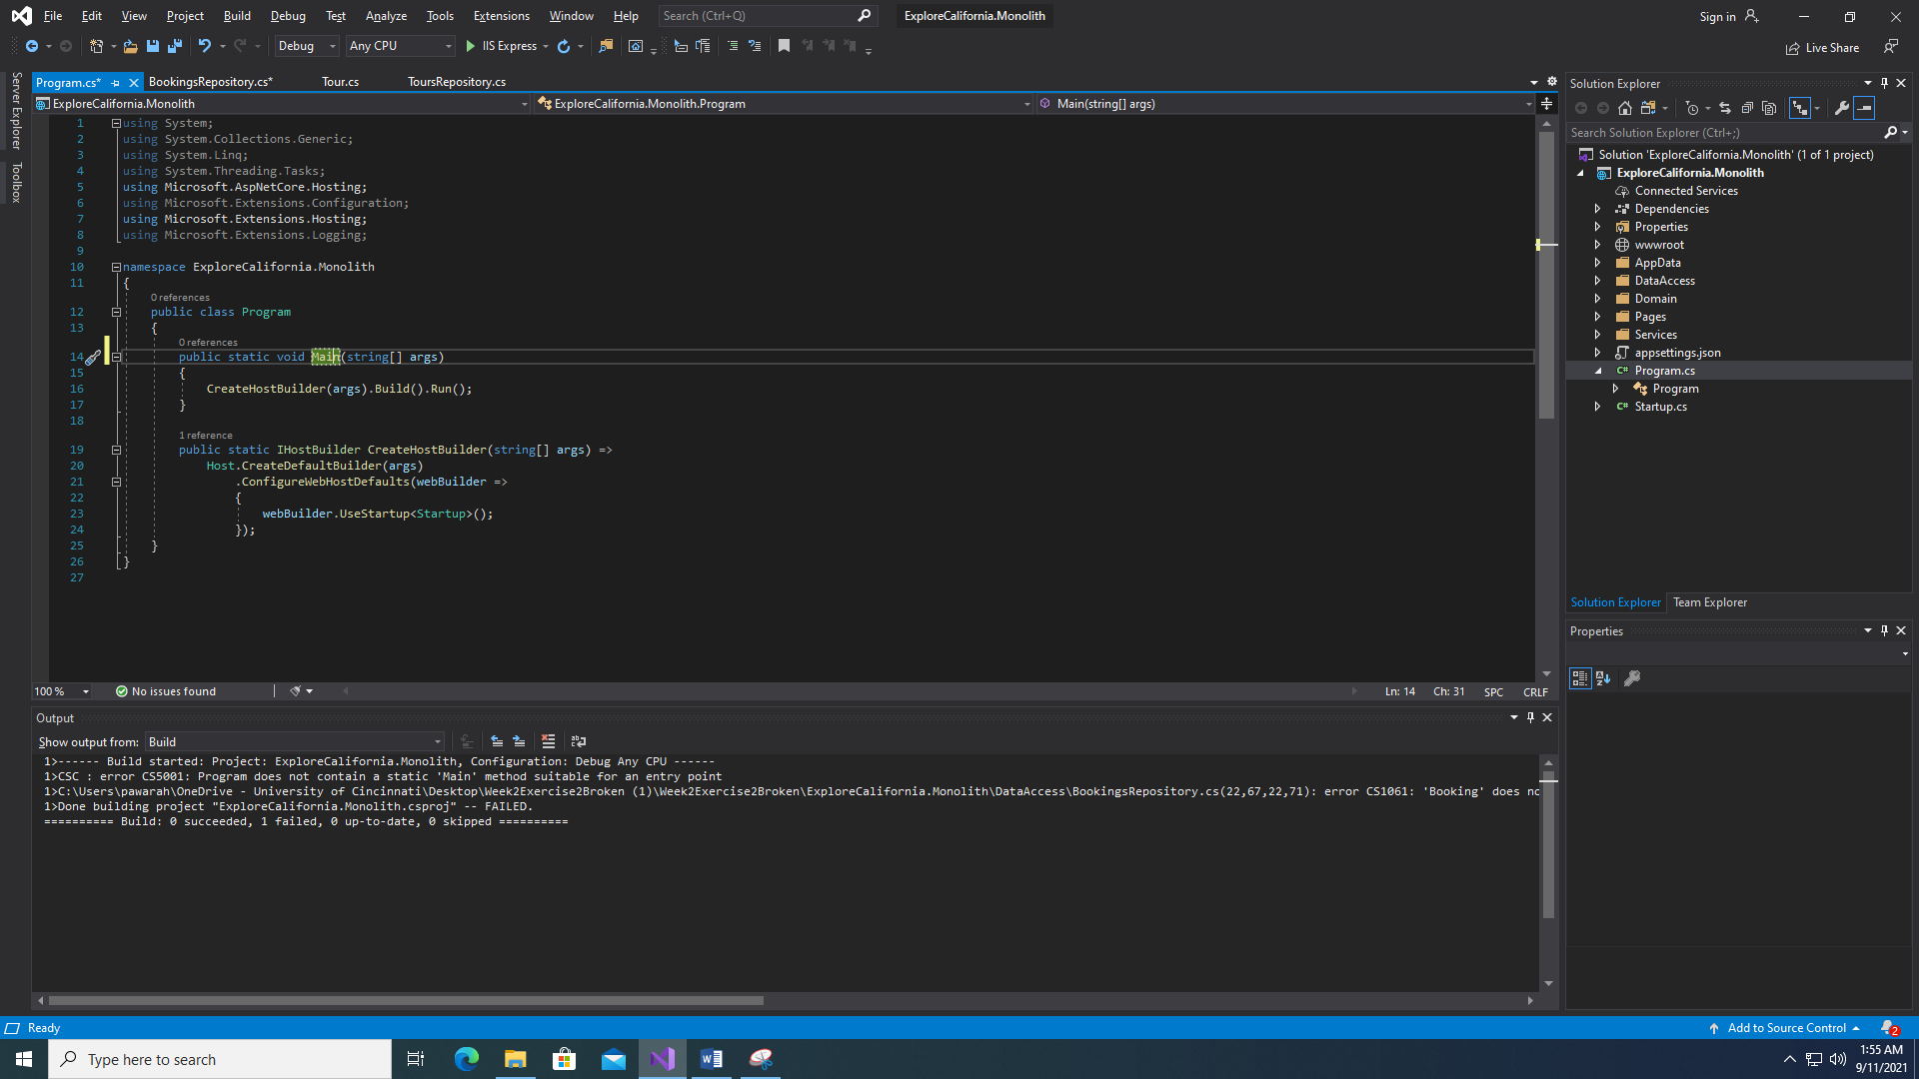

**ERROR**

Application is failing

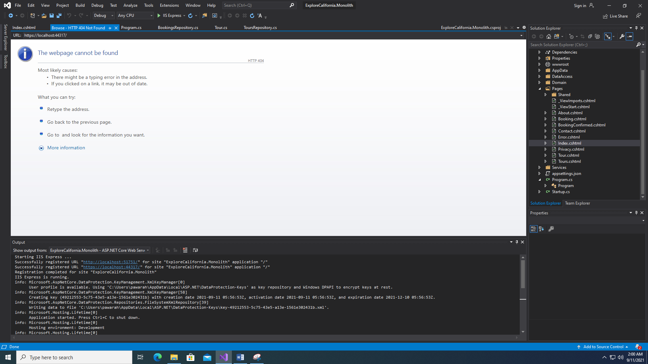

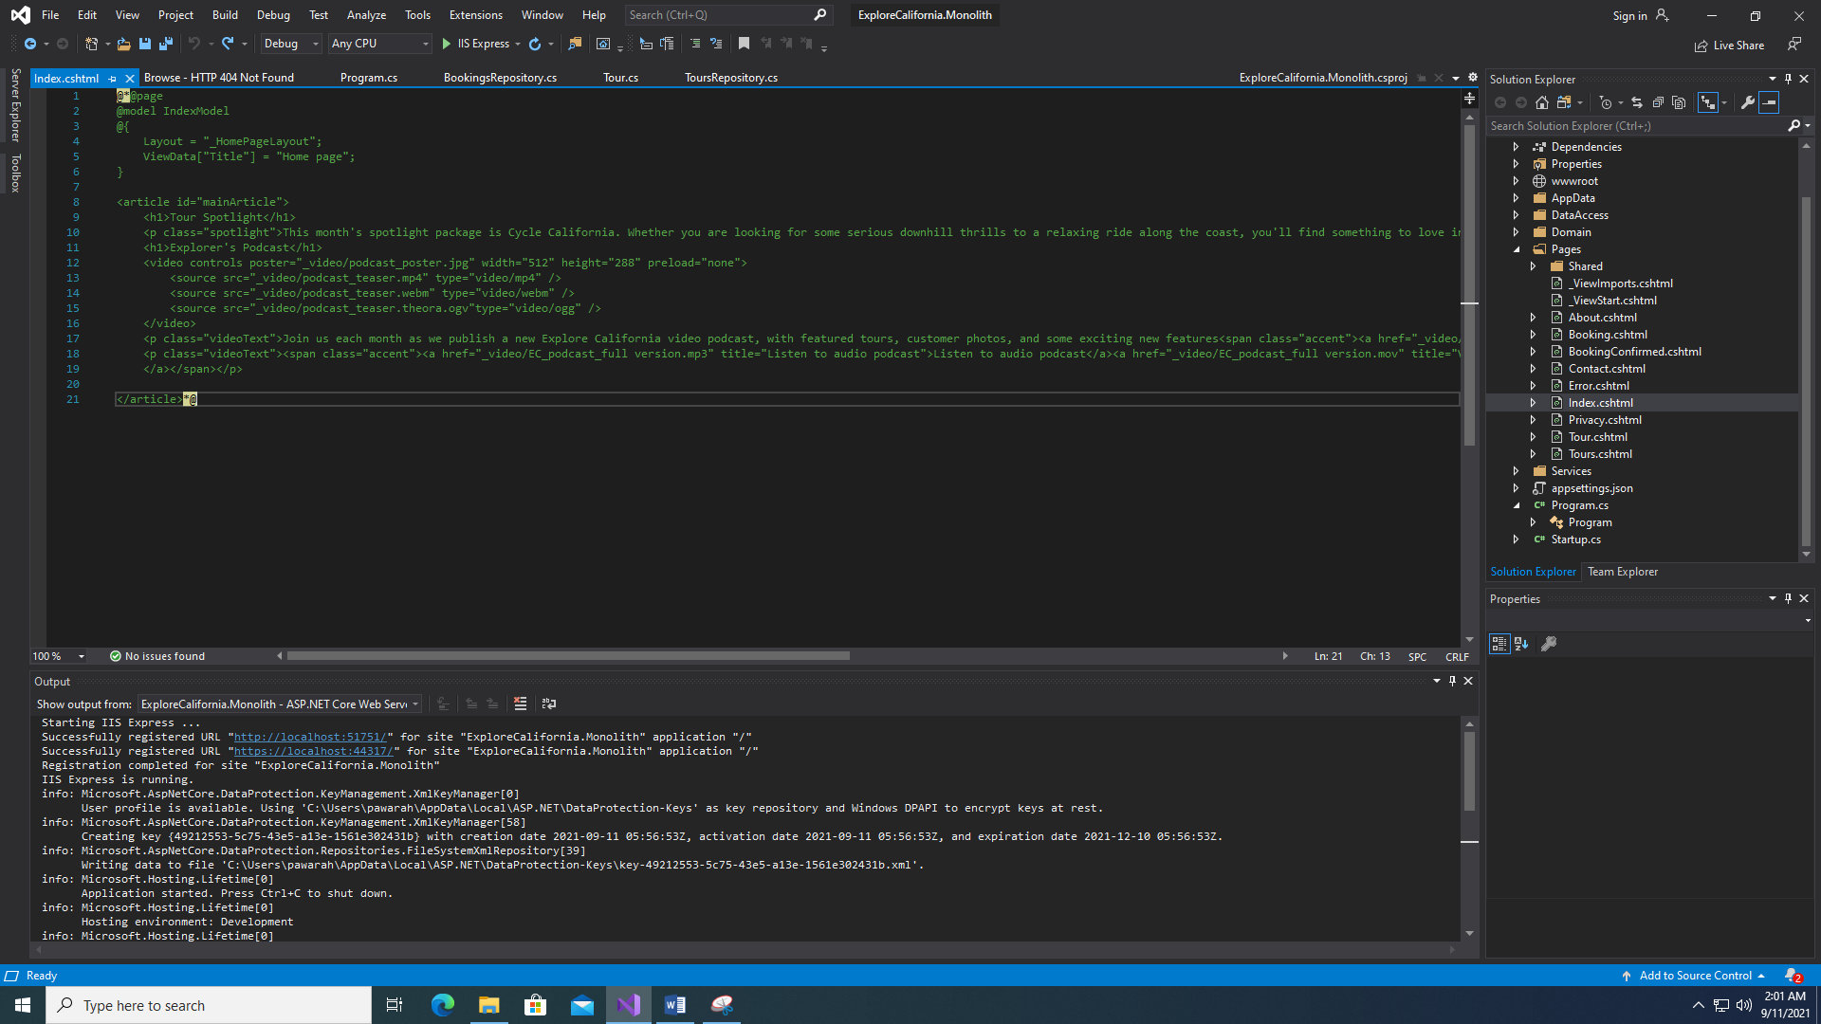

**Solution –**

Uncomment the index.html page

